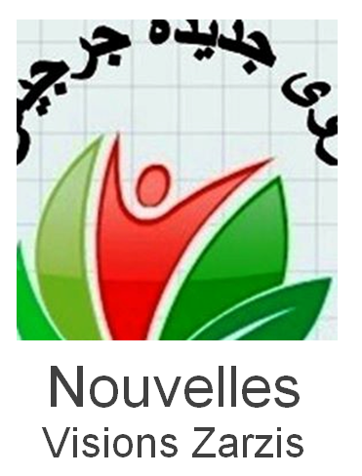

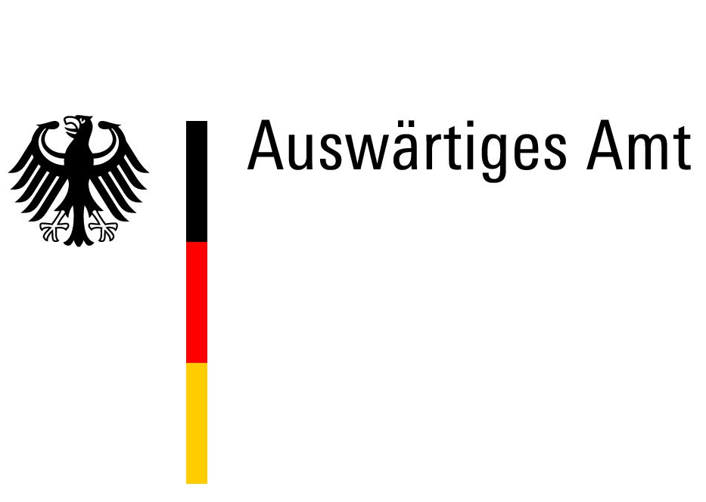
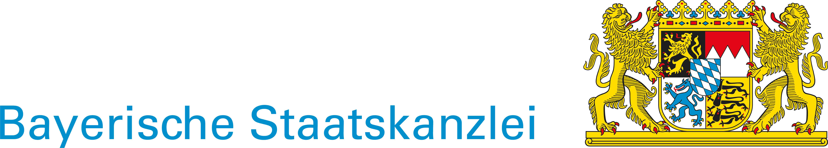
Claus Sixt
Phone.: 0049 (0)176 92 66 23 90
Association of European Education [Gesellschaft für Europabildung e.V.]
Petersburger Straße 94
10247 Berlin

Please, send the completed form to
claus.sixt@europabildung.org

Registration

“Teaching Political Tools to Young People“
from Saturday, the 8 of December to Saturday, the 15 of December 2018 in Djerba, Tunisia

Name and surname :
Street, Town:
Mobile:
Email:
Age // Date of birth // Male / Female
Nationality
Your passport number // date of expiry
I prefer double room / a single room (+ 55 EUR additional fee)
YourEnglish ist fluent / good / satisfactory / poor / none
Your French is fluent / good / satisfactory / poor / none
Your Arabic is fluent / good / satisfactory / poor / none
Are/were you engaged in a political party? Yes / No
Are you engaged in a NGO? Yes / No
Do you need to be freed from school/university/work for the project? Yes / No

In case you are involved in an organisation / NGO / party, please provide its main aims, its website and your involvement (on a regular basis, as a volunteer) in the organisation, your usually work with the target group/s (age, interests, background, etc)::

Please describe your experience as a youth worker or a volunteer in the youth field (if not already done in the question above:

In case you have any previous experience in projects of political participation, please describe these experiences, (if not already described):

Please describe your motivation for attending this course. What do you expect from this training course?

How do you plan to apply the experience and knowledge you will gain during this training?

Emergency contact person. Please give name, phone number and e-mail of your emergency contact. Include the country code (e.g. +49 for Germany)

It is possible to prolong your stay individually on your own costs in Tunisia. If this increases the costs for the flight, you have to pay the extra expenses.
I would like to extend my stay. Please contact me.

I permit you to

publish photos of me which are taken during the project.
to forward my email address to participants of the project.
to forward my personal data to employees of Europabildung and the funding agencies.
(You have to cross this otherwise I can’t do the report and the billing.)

The participation fee is 195 EUR (double room)/ 250 EUR (single room) for participants from Germany and 35 EUR (double room) / 90 EUR (single room) for participants from Ukraine. The expenses from your hometown to the airport and the expenses during the free day are not covered.
As soon as participants of Germany got the confirmation for the participation, please transfer the fee to:
Gesellschaft für Europabildung
Bank für Sozialwirtschaft
IBAN DE38 1002 0500 0001 0074 00
Subject: Vorname Name, Teaching Political Tools
Participants of Tunisia will be informed about payment.

As of the 15 of September 2018

